

Topic test 2
Name: __________________________________

Chapter 10: Properties of derivatives

• Time allowed: 45 minutes
• CAS calculators may be used.
• Part A: 6 multiple-choice questions (6 marks)
• Part B: 9 short answer questions (31 marks)
• Part C: 5 analysis questions (23 marks)
Part A
6 multiple-choice questions
1 mark each: 6 marks
Circle the correct answer.
1 When a function, f(x), is decreasing, which of the following is true?
A the graph of f(x) is flat
B the graph of f(x) slopes upwards
C f(x) < 0
D the graph of f(x) slopes downwards
E f(x) = 0

[1 mark]
2 y = −3x3 + 5x2 + 16x + 20. At x = 2, y is:
A increasing
B stationary
C negative
D decreasing
E positive
[1 mark]
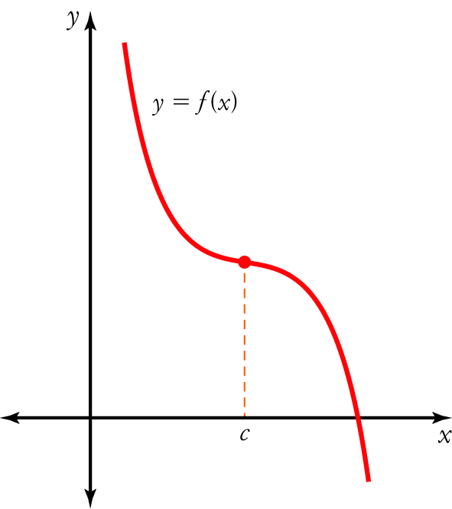
3 For the function shown on the right, which of the following is true?
A f ʹ(x) > 0 when x > c
B f ʹ(x) < 0
C f ʹ(x) < 0 when x < c and f ʹ(x) > 0 when x > c
D f ʹ(x) < 0 when x  c
E f ʹ(x) > 0

[1 mark]
4 If f(x) = 7x2 − 8x + 5, then f ʹ(2) =
A 36
B 17
C 20
D 49
E 3

[1 mark]
5 The rate of change of f(x) = −4x3 + 10x2 − 15 at x = −2 is:
A −88
B −8
C 57
D 88
E 8

[1 mark]
6 The antiderivative of −24x5 is:
A 120x4 + c
B −4x6
C 6x6 + c
D −4x6 + c
E −6x6 + c

[1 mark]
Part B
9 short answer questions
31 marks
Show your working where appropriate.
1 State whether the function f(x) = −3x4 + 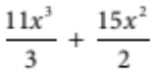 − 17 is increasing, decreasing or stationary at:
a x = 2 ____________________
b x 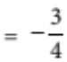 ____________________
c x = 1 ____________________
[7 marks]
2 p(x) = −5x4 + 3x3 + 7x − 16. Find:
a pʹ(x) ____________________
b pʹ(2) ____________________
[2 marks]
3 If f ʹ(x) = 2x2 + 9x − 14 and gʹ(x) = 4x3 − 5x2 + x, calculate the derivative of 5f(x) − 2g(x).

[4 marks]
4 Find the derivatives of the following functions.
a g(x) = 8x4 − 12x3 + 7x + 14

b h(m) = 14m − 8m3 − 12 + 7m2

[2 marks]
5 Find the derivative of the function y = (5x2 + 3x)2.

[2 marks]
6 Find the derivative of the function y = (x + 7)(2x − 3)2.

[2 marks]
7 f(x) = 8 + 10x − 4x2 + 5x3.
a Find the average rate of change of f(x) from x = 0 to x = 4.

b Find the instantaneous rate of change at:
i x = 0 ____________________
ii x = 4 ____________________
iii x = 2 ____________________
c Compare the average rate of change and the instantaneous rates of change.

[8 marks]
8 Find two antiderivatives of f(x) = 10x4 + 6x2 − 12.

[2 marks]
9 Find y if 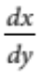 = 21x6 − 9x2 + 4x.

[2 marks]
Part C
5 analysis questions
23 marks
Show your working where appropriate.
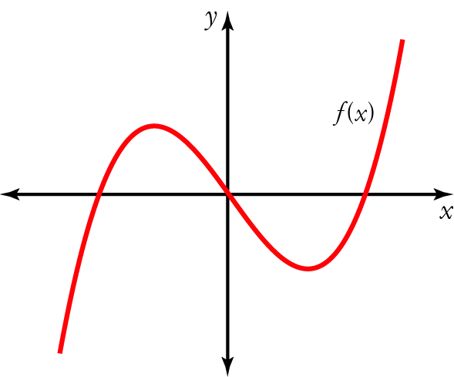
1 The graph of a function is shown on the right.
Use it to sketch a graph of the corresponding gradient function.

[4 marks]
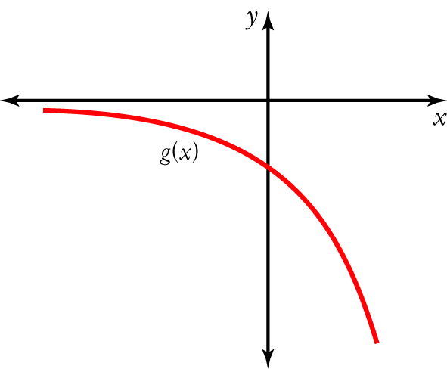
2 The graph of a gradient function is shown on the right.
Use it to sketch a graph of the corresponding function.

[4 marks]
3 Find the equation of the tangent to the curve y = x4 − 3x3 + 7x − 2 at x = 2.

[5 marks]
4 A subatomic particle passes through a linear accelerator. At speeds of less than 3 × 107 m/s its distance in metres from the start is given by:
s = 5 × 1010 t2 + 10 000t, where t is in seconds.
The linear accelerator is about 8 km long.
The derivative of distance is the rate of change of distance and so it is a measure of the particle’s speed.
Find the time taken for the particle to reach a speed of 3 × 107 m/s and the distance that the particle must travel through the accelerator to reach that speed.

[5 marks]
5 The rate of water flow into a dam is given by R = 500 + 20t Lh⁻1. If there is 15 000 L initially in the dam, how much water will the dam hold after 10 hours?

[5 marks]
Total marks: 60
Answers
Part A [1 mark each]
1 The derivative is negative so the graph slopes downwards.
E [1 mark]
2 yʹ = −9x2 + 10x + 16, so when x = 2, yʹ = 0
y is stationary.
B [1 mark]
3 The derivative is the same as the gradient (slope). The function has a negative gradient for all values of x except when x = c, where the graph is stationary.
D [1 mark]
4 f ʹ(x) = 14x − 8 so f ʹ(2) = 20.
C [1 mark]
5 The derivative gives the rate of change. f ʹ(x) = −12x2 + 20x so f ʹ(−2) = −88.
A [1 mark]
6 f(x) = −24x5, so F(x) = 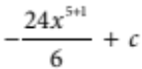 = −4x6 + c.
D [1 mark]
Part B
1 f(x) = −3x4 + − 17
f ʹ(x) = −12x3 + 11x2 + 15x
= x(−12x2 + 11x + 15) [1 mark]
a f ʹ(2) = 2(−12 × 22 + 11 × 2 + 15) = −22 [1 mark]
f ʹ(2) < 0
f(x) is decreasing. [1 mark]
b f ʹ 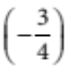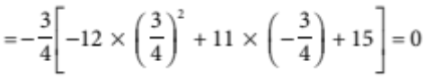 [1 mark]
f ʹ = 0
f(x) is stationary. [1 mark]
c f ʹ(1) = 1(−12) × 12 + 11 × 1 + 15 = 14 [1 mark]
f ʹ(1) > 0
f(x) is increasing. [1 mark]
[7 marks]
2 a pʹ(x) = −20x3 + 9x2 + 7 [1 mark]
b pʹ(2) = −20 × (2)3 + 9 × 22 + 7 = −117 [1 mark]
[2 marks]
3 D[5f (x) − 2g(x)] = 5f ʹ(x) − 2gʹ(x) [1 mark]
= 5(2x2 + 9x − 14) − 2(4x3 − 5x2 + x) [1 mark]
= 10x2 + 45x − 70 − 8x3 + 10x2 − 2x [1 mark]
= −8x3 + 20x2 + 43x − 70 [1 mark]
[4 marks]
4 a gʹ(x) = 32x3 − 36x2 + 7 [1 mark]
b hʹ(m) = 14 − 24m2 + 14m [1 mark]
[2 marks]
5 y = (5x2 + 3x)2 = 25x4 + 30x3 + 9x2 [1 mark]
yʹ = 100x3 + 90x2 + 18x [1 mark]
[2 marks]
6 y = (x + 7)(2x − 3)2
= (x + 7)(4x2 − 12x + 9)
= 4x3 + 16x2 − 75x + 63 [1 mark]
yʹ = 12x2 + 32x − 75 [1 mark]
[2 marks]
7 a f(0) = 8 + 10 × 0 − 4 × 02 + 5 × 03 = 8 [1 mark]
f(4) = 8 + 10 × 4 − 4 × 42 + 5 × 43 = 304 [1 mark]
Average rate of change = 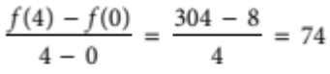 [1 mark]
b Instantaneous rate of change = f ʹ(x) = 10 − 8x + 15x2 [1 mark]
i f ʹ(0) = 10 − 0 + 0 = 10 [1 mark]
ii f ʹ(4) = 10 − 8 × 4 + 15 × 42 = 218 [1 mark]
iii f ʹ(2) = 10 − 8 × 2 + 15 × 22 = 54 [1 mark]
c The average rate of change is not the same as the average of the instantaneous rates. [1 mark]
[8 marks]
8 F(x) = 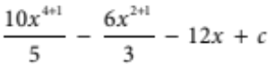= 2x5 + 2x3 − 12x + c
Two possible antiderivatives are 2x5 − 3x3 + 2x2 + 10 and 2x5 − 3x3 + 2x2 − 10. [1 mark each]
[2 marks]
9 y = 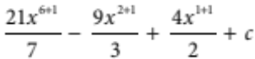 = 3x7 − 3x3 + 2x2 + c [1 mark + 1 mark for + c]
[2 marks]
Part C
1 The key features of the graph of the gradient function, g(x), are found by examining the graph of
the function, f(x). These are:
• f(x) is stationary on either side of the y-axis. This means that g(x) will be zero at these x values.
[1 mark for showing this feature on the graph]
• f(x) has a negative slope between the stationary points. This means that g(x) will be negative between these
x values.
[1 mark for showing this feature on the graph]
• Looking from left to right, f(x) has a positive slope on the left of the first stationary point and on the right of the second stationary point. This means that g(x) will be positive at these x values.
[1 mark for showing this feature on the graph]
• The steepness of the graph of g(x) is determined by the steepness of the tangent to the graph of f(x).
[1 mark for showing this feature on the graph]
[4 marks]
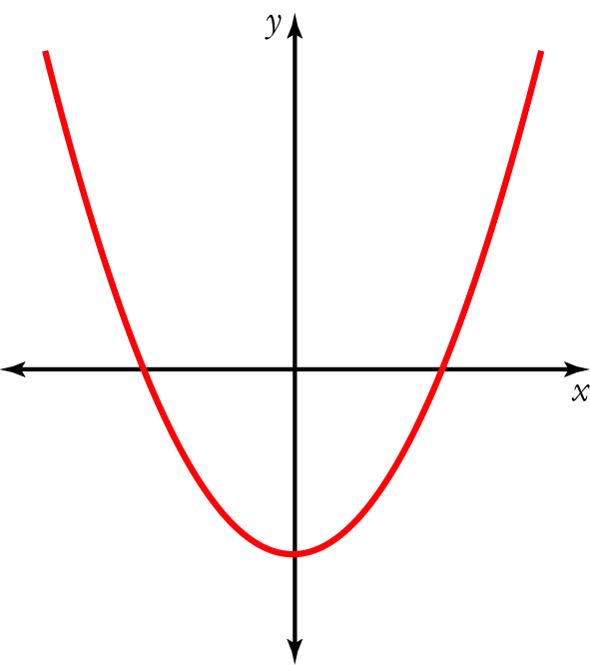
2 The key features of the graph of the function, f(x), are found by examining the graph of the gradient function, g(x). These are:
• g(x) does not intercept the x-axis. This means that f(x) does not have any stationary points.
[1 mark for showing this feature on the graph]
• g(x) is negative for all values of x. This means that f(x) is decreasing for all values of x.
[1 mark for showing this feature on the graph]
• The values of g(x) indicate the steepness of the tangent to the graph of f(x). Higher values of g(x) indicate that the graph of f(x) will be steeper than at lower values of g(x).
[2 marks for showing this feature on the graph]
[4 marks]
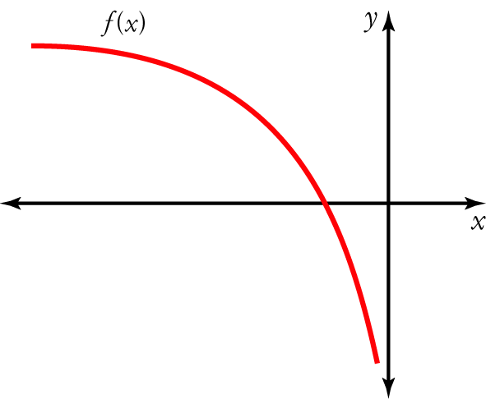
3 When x = 2, y = 24 − 3 × 23 + 7 × 2 − 2 = 4 [1 mark]
yʹ = 4x3 − 9x2 + 7
When x = 2, yʹ = 4 × 23 − 9 × 22 + 7 = 3 [1 mark]
The tangent passes through (2, 4) and has a gradient of 3.
Equation of the tangent: y − y1 = m(x − x1) [1 mark]
(y − 4) = 3(x − 2) [1 mark]
y − 4 = 3x − 6
y = 3x − 2 [1 mark]
[5 marks]
4 v = 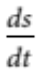 = 2 × 5 × 1010t + 10 000 = 1011t + 10 000 [1 mark]
Let v = 3 × 107
3 × 107 = 1011t + 10 000 [1 mark]
1011t = 3 × 107 − 10 000
1011t = 2.999 × 107
t  2.999 × 10−4 [1 mark]
Let t  2.999 × 10−4:
s = 5 × 1010 (2.999 × 10−4)2 + 10 000 × 2.999 × 10−4
 4500 [1 mark]
It takes about 0.3 milliseconds and about 4.5 km for the particle to reach a speed of 3 × 107 m/s. [1 mark]
[5 marks]
5 The antiderivative of R gives an expression for the volume of water in the dam. [1 mark]
Let V be the antiderivative of R.
V = 500t + 10t2 + c [1 mark]
V = 15 000 at t = 0, so 15 000 = 500 × 0 + 10 × 02 + c
c = 15 000 so V = 500t + 10t2 + 15 000 [1 mark]
Let t = 10: V = 500 × 10 + 10 × 102 + 15 000 = 21 000 [1 mark]
The volume of the dam after 10 hours is 21 000 L. [1 mark]
[5 marks]

